Synopsis

**Introduction**

Design of Experiments (DOE)is a crucial methodology used in various industries such as manufacturing, engineering, and research. It enables professionals to analyze and optimize processes by determining the relationships between different variables and their impact on outcomes. However, managing and accessing past DOE data is often a challenge, leading to inefficiencies in decision-making.

The DOE Mobile Application aims to address this issue by providing a user-friendly platform that allows users to search previous DOE records and create new DOE experiments with ease. The application will serve as a centralized system for DOE management, ensuring that researchers and professionals can retrieve relevant information quickly and effectively.

**Aim**

The primary aim of this project is to develop a mobile application that allows users to efficiently manage Design of Experiments (DOE) data by:

* **Searching for previous DOE records** using multiple input parameters.
* **Adding new DOE experiments** with structured inputs and appropriate parameters.
* **Displaying results with matching DOE parameters** to assist users in making data-driven decisions.

**Objectives**

The DOE Mobile Application will be designed with the following objectives:

* Provide an intuitive and user-friendly interface for managing DOE records.
* Enable users to search and retrieve previous experiments using multiple filters.
* Facilitate the addition of new experiments with structured data input.
* Enhance research efficiency by providing past experimental data for reference.
* Ensure secure authentication and data privacy through login credentials.
* Optimize search algorithms to deliver accurate and relevant results efficiently.

**Abstract**

The DOE Mobile Application is a research-oriented platform designed to streamline the management of DOE records. The application allows users to search for previous experiments based on specific input parameters and add new experiments to the database. The app ensures that users can quickly find relevant data, thus improving research efficiency and decision-making.

This application is beneficial for professionals in industries where experiments and statistical analysis are critical. By providing a structured approach to DOE record management, the application minimizes the redundancy of repeated experiments and enables data-driven decision-making.

**Application Architecture**

The architecture of the DOE Mobile Application is designed to ensure optimal performance, security, and usability. It consists of the following components:

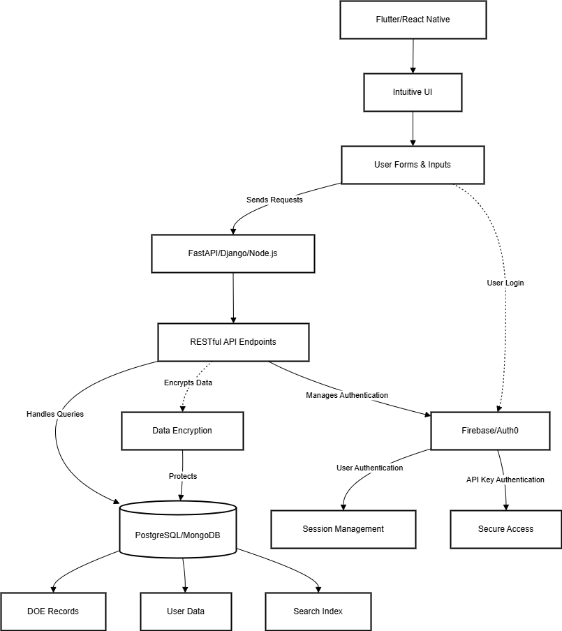

**User Flow**

The user flow ensures a seamless experience for users from registration to retrieving DOE records.

